Title
Name Surname ^{1,*}, Name Surname ² and Name Surname ²
¹ IAMU member university, Country
² Second affiliation, Country
* Corresponding author: author@university.xx

Keywords: first keyword; second keyword; third keyword (three to five pertinent keywords should be listed)

These instructions provide authors with guidelines for typing camera-ready abstracts for the 26th International Association of Maritime Universities Conference Book. This electronic document is a “live” template and is used to format the abstract and style the text. Abstracts are limited to one page of text (and a second page may only be provided for relevant tables/figures). The abstract should clearly explain the content and relevance of the work. Authors must keep their camera-ready abstracts in the A4 paper size, Times New Roman font is strictly required, all margins, line spaces and text fonts are prescribed, and page numbers should not be added.
The theme of the IAMUC is “Human-centred digital oceans: Educating safe & green global maritime professionals”. When submitting your abstract, please indicate one of the following theme categories in which the abstract will be registered and reviewed:
- Environmental topics
- Technology topics
- Economic topics
- Social topics
- Policy topics.

The abstract submission deadline is 1st of February 2026. Authors should upload their abstracts to the manuscript system, which will open in early December 2025.
Submission of an abstract will be taken to imply that it represents an original work and that it has not been previously published or considered elsewhere for publication. Please be aware that authors are responsible for the English language quality of the text. Notification of acceptance will be given by 1st of March 2026.
The accepted abstract will be assigned by the International Program Committee for oral or poster presentation, not only based on the author's preference indicated in the Easy chair submission, but also on the quality of the abstract and number of the oral presentations allocated.
All presented abstracts will be published in the Conference Book with assigned ISSN identifier. The authors will be invited to submit a full paper version for inclusion in the IAMU Conference Proceedings. Instructions to prepare the full paper will be emailed together with the notification of the abstract. The full paper will be requested by 1st of May 2026.

References
References cited in the paper are listed alphabetically. The authors should verify all references. IAMUC uses Harvard citation and reference style. Cite references in the text by name and year in parentheses. Some examples:
- Negotiation research spans many disciplines (Thompson 1990).
- This result was later contradicted by Becker and Seligman (1996).
- This effect has been widely studied (Abbott 1991; Barakat et al. 1995a, b; Kelso and Smith 1998; Medvec et al. 1999, 2000).
The list of references should only include works that are cited in the text and that have been published or accepted for publication. Some examples:
- Journal article:
Gamelin F.X., Baquet G., Berthoin S., Thevenet D., Nourry C., Nottin S., Bosquet L. (2009) Effect of high intensity intermittent training on heart rate variability in prepubescent children. Eur J Appl Physiol 105:731-738. Available at: https://doi.org/10.1007/s00421-008-0955-8
- Article by DOI:
Slifka M.K., Whitton J.L. (2000) Clinical implications of dysregulated cytokine production. J Mol Med. Available at: https://doi.org/10.1007/s001090000086
- Book:
South J., Blass B. (2001) The future of modern genomics. Blackwell, London
- Online document:
Cartwright J. (2007) Big stars have weather too. IOP Publishing PhysicsWeb. Available at: http://physicsweb.org/ articles/news/11/6/16/1. Accessed 26 June 2007
- Dissertation:
Trent J.W. (1975) Experimental acute renal failure. Dissertation, University of California
- Regulations, standards or legal acts:
Constitution of the Republic of Croatia (2010) Narodne novine, 2010(76), pp. (if known).

Illustrations should contain only English labels and be prepared in the final published size, not oversized or undersized. Each illustration must have a caption (Figure 1).
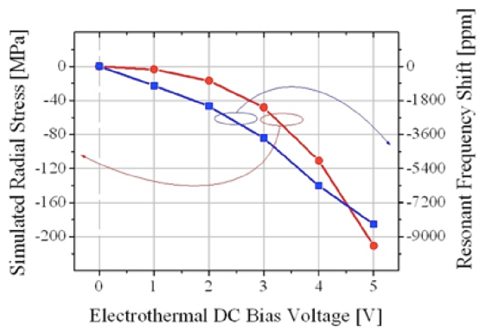
Figure 1. An example of a figure.

Tables have to be submitted as editable text and not as images. Each table has to have a caption (Table 1).
Table 1. An example of a table.
An example of a column heading | Column A | Column B
First entry | 1 | 2
Second entry | 3 | 4
Third entry | 5 | 6

Acknowledgements
If a funding has been provided for the research, please include brief information on the program or type of grants and awards.

